Physics Stage 2: Nuclear Physics Test 2012

Name: _________________________________________________ (42 marks)

- Within a nuclear reactor, uranium-235 is bombarded by a neutron to split into two daughter products also emitting two neutrons. Part of the nuclear equation is shown below.

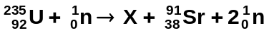

  - Write the nuclide for the missing daughter product labelled X. ________________
(1 mark)
  - What is the atomic and mass numbers of the daughter product:
Mass number ________ Atomic number ________ (1 mark)
- In terms of the properties of alpha and beta radiation, explain why alpha radiation cannot penetrate paper but beta radiation can. (4 marks)

____________________________________________________________________________
____________________________________________________________________________
____________________________________________________________________________
________________________________________________________________________________________________________________________________________________________
____________________________________________________________________________
- For an atomic bomb to explode the amount of uranium-235 must reach critical mass and then the fission reaction created from a neutron induced chain reaction becomes uncontrollable. What is a neutron-induced chain reaction and why does it need critical mass to explode?
(4 marks)
_______________________________________________________________________________________________________________________________________________________________________________________________________________________________________________________________________________________________________________________________________________________________________________________
___________________________________________________________________________
______________________________________________________________________________________________________________________________________________________
___________________________________________________________________________

- A radioactive isotope has a count of 3.85 x 10³ decays in one hour. Calculate the activity of the source. (2 marks)

- Calculating the binding energy per nucleon in MeV of the helium-3 atom given the mass of
He-3 = 5.00 x 10⁻²⁷ kg. (4 marks)

- If the original activity of a sample is 42.0 kBq and it has a half-life of 4.00 days, what will be the activity 12.0 days? (3 marks)

- A radiation source and a detector can be used to measure the thickness of very thin aluminium foil during manufacture. Select, from the table, a suitable radioisotope to be used as a radiation source.

RADIOISOTOPE | MOST USEFUL RADIATION EMITTED | HALF-LIFE
Americium-241  Cesium-137  Cobalt-60  Iodine-131  Radium-223  Strontium-90 | alpha  gamma  gamma  beta  alpha  beta | 432 years  30 years  5.27 days  8.04 days  11.4 years  29 years

Choice: ____________________________________________ 1 mark)
Reason for choice: (3 marks)

____________________________________________________________________________

____________________________________________________________________________

____________________________________________________________________________

____________________________________________________________________________

____________________________________________________________________________
- The forming of a new element during radioactive decay is called transmutation. Explain why emitting alpha and beta radiation causes a transmutation but emitting gamma radiation does not. (3 marks)

____________________________________________________________________________

____________________________________________________________________________

____________________________________________________________________________

____________________________________________________________________________

____________________________________________________________________________

____________________________________________________________________________

____________________________________________________________________________
- A miner in a uranium mine does not know that he is exposed to a radon-222 gas leak. The gas is an alpha emitter, and it has a very long half life. The gas he breathes in is not eliminated from the body as it settles into the tissue of his lung. The radon in his body has an estimated activity of 3.40kBq which can be considered constant. Each decay of the isotope releases 3.8 x 10⁻¹² J of energy into his body. One month (30 days) later, the accident is discovered, and management realise that he was been exposed to the gas.

- Calculate the total energy the miner absorbed into his lungs during the 30 days since he breathed in the radon. (2 marks)

- Calculate the absorbed dose he received in one month if he has a mass of 75 kg. (If you were unable to obtain a value for (a) above use 0.035 J) (2 marks)

- Calculate the dose equivalent if the alpha radiation has a quality factor of 20. (2 marks)

- Should the miner be concerned about his exposure? Explain. (2 marks)

________________________________________________________________________

________________________________________________________________________

________________________________________________________________________

________________________________________________________________________

- Determine the half-life of the substance from the graph.

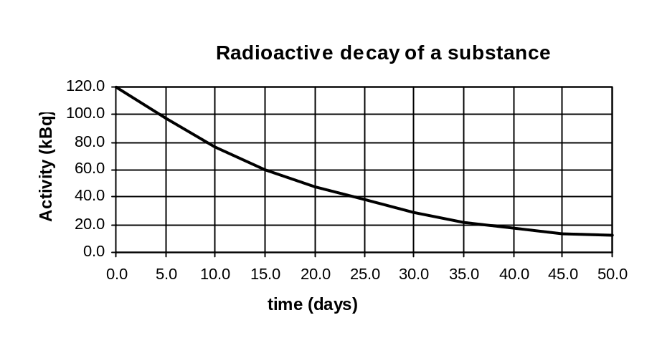

Half-life = _________________________ (1 mark)

- Food can be preserved by irradiating it with nuclear gamma radiation. Meat typically requires an equivalent dose of 1000 Sv to sterilize it. How much energy does 2.0 kg of meat absorb when it undergoes sterilization? (2 marks)

Comprehension: Read the article then answer the questions. (10 marks)
New Scientist in April 1991.

Long Wait Ends For Medical Cyclotron

More than 20 years after it was first proposed, Australia’s first medical cyclotron was installed this month at the Royal Prince Alfred Hospital in Sydney.

The opening of the cyclotron ends many years of dispute as to where it should be sited. It took the Australian Nuclear Science and Technology Organisation (ANSTO) a long time to convince the government that the equipment should be located at a hospital and not with the research reactor at Lucas Heights in Sydney’s southern suburbs. Rex Boyd, director of the cyclotron project, says U.S. experience showed that doctors would not send seriously ill patients to a facility away from a major hospital.

By September, the National Medical Cyclotron will be cranking out radioisotopes for use in the hospital’s new positron emission tomography (PET) centre, which is expected to cater for about 1000 patients a year. PET scans help doctors to diagnose heart disease, cancer, and numerous brain disorders such as Alzheimer’s disease and epilepsy.

It will produce radioisotopes previously unavailable in Australia, the most important of which are carbon-11, nitrogen-13, oxygen-15 and fluorine-18. These isotopes are useful only for short periods of time before they break apart, which is why scientists and clinicians cannot simply import them form abroad.

(A radioisotope is a radioactive form of an element which differs in mass from the more stable form. Radioisotopes break up spontaneously emitting high energy particles. They can be used medically as tracers and for measuring concentrations of substances.)

According to Boyd, the A$22 million cyclotron - made in Belgium by Ion Beam Applications (IBA) can produce a wide variety of radioisotopes because it can accelerate either protons or deuterons. The radioisotopes are created when those particles strike a specially prepared target at high velocity. The isotopes then travel down two “beam lines” from the cyclotron to a laboratory where they are purified and turned into biologically active radio-pharmaceuticals.

It is hoped that the sale of longer-lived radioisotopes will cover the facility’s annual A$3 million operating cost. IBA is also supplying a much smaller machine to the Austin Hospital in Melbourne. The mini-accelerator, as it is called, will produce radioisotopes for PET applications alone.

Leigh Dayton, Sydney.

1. One of the radioisotopes which will be produced by the cyclotron is nitrogen -13. With reference to the article, explain in general terms what happens in the cyclotron to produce the nitrogen-13. (there is no need to write an equation) (2 mark)
_____________________________________________________________________________
______________________________________________________________________________
______________________________________________________________________________
______________________________________________________________________________

2. a. What reason is given for Australia not importing supplies of fluorine-18 and oxygen-15 for example? Explain. (2 mark)

______________________________________________________________________________
______________________________________________________________________________
______________________________________________________________________________
______________________________________________________________________________

- Another important medical tracer which is currently produced at Lucas Heights is technetium 99. Tc-99 has a half-life of 6.00 hours. If a 20.0 g sample of Tc-99 is produced at 6.00 am, what mass will still be active at 6.00 am the next day? (2 mark)

3. All the major diagnostic hospitals around Australia use Tc-99. Supplies are dispatched from Lucas Heights to all capital cities every 3 days or so. However, it is not Tc-99 which is sent but molybdenum-99 instead. Mo-99, which has a half-life of 72 hours transmutes to Tc-99 when it decays. The Tc-99 is then withdrawn by the doctors as required.

a. (i) Complete the nuclear equation to show the missing particle. (1 mark)

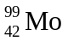 → 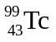 +

(ii) What type of radiation is this? ________________________ (1 mark)

b. Explain the advantage of sending Mo-99 instead of Tc-99. (2 marks)
______________________________________________________________________________
______________________________________________________________________________
______________________________________________________________________________
______________________________________________________________________________

